**USER MANUAL**

**Steps to install Python on Windows**

We have provided step-by-step instructions to guide you and ensure a successful installation. Whether you are new to programming or have some experience, mastering how to install Python on Windows will enable you to utilize this potent language and uncover its full range of potential applications.

**Downloading the Python Installer**

To download Python on your system, you can use the following steps.

* Visit the official download page for Python(https://www.python.org/downloads/) on the Windows operating system.
* Locate a reliable version of Python 3, preferably version 3.10.11, which was used in the development of the game
* Choose the correct link for your device from the options provided: either Windows installer (64-bit) or Windows installer (32-bit) and proceed to download the executable file.

**Running the Executable Installer**

* Once you have downloaded the installer, open the .exe file, such as python-3.10.11-amd64.exe, by double-clicking it to launch the Python installer.
* Choose the option to Install the launcher for all users by checking the corresponding checkbox, so that all users of the computer can access the Python launcher application.
* 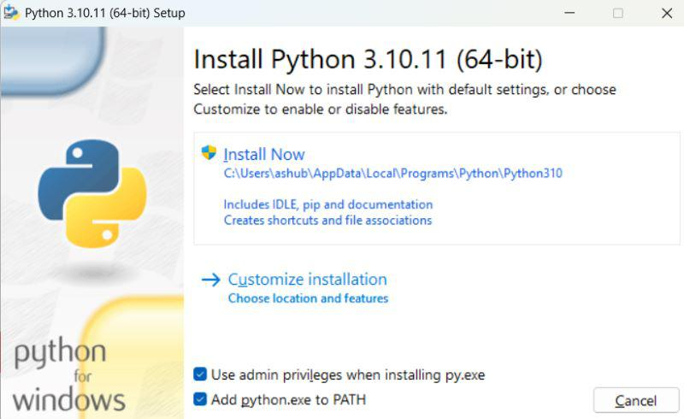Enable users to run Python from the command line by checking the Add python.exe to PATH checkbox.

**Setup Progress**

After Clicking the Install Now Button the setup will start installing Python on your Windows system. You will see a window like this.

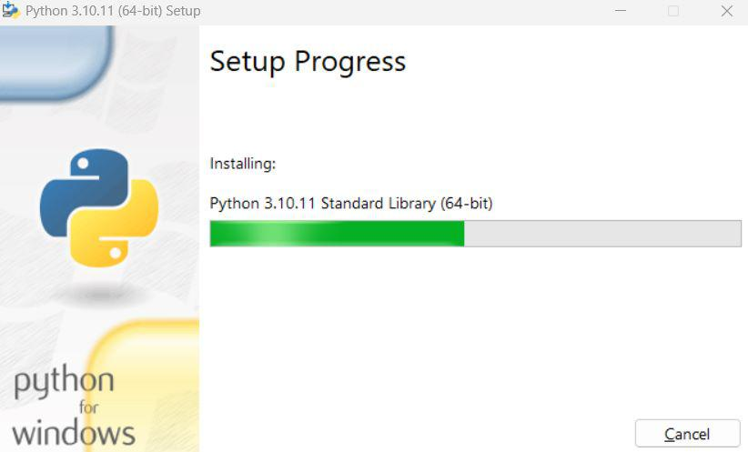

**Final Installer Window**

After completing the setup. Python will be installed on your Windows system. You will see a successful message.

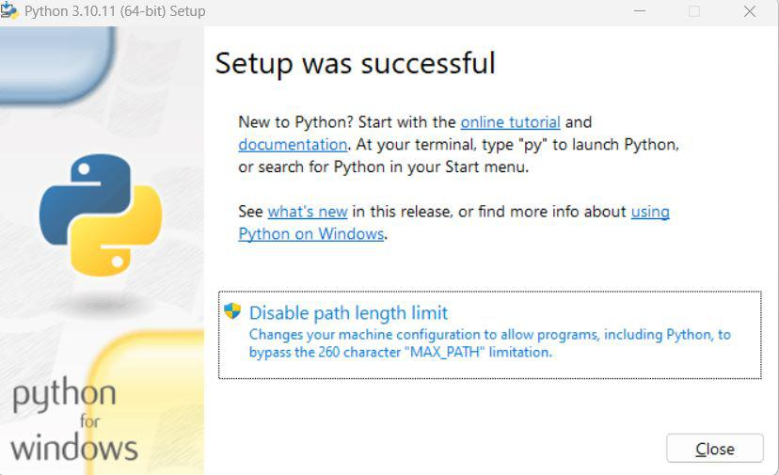

**Verify the Installation**

Close the window after successful installation. You can check if the installation of Python was successful by using either the command line or the Integrated Development Environment (IDLE), which you may have installed.

To access the command line, click on the Start menu and type “cmd” in the search bar. Then click on Command Prompt.

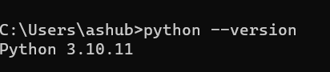python –version

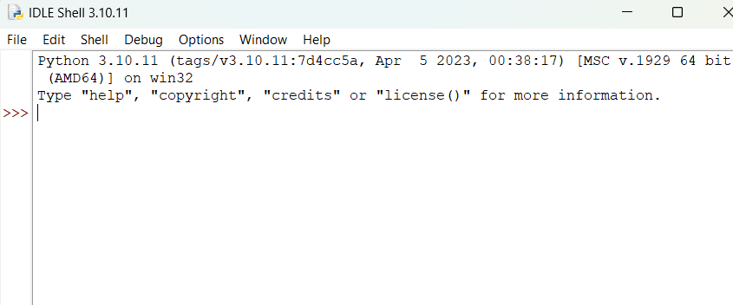You can also check the version of Python by opening the IDLE application. Go to Start and enter IDLE in the search bar and then click the IDLE app, for example, IDLE (Python 3.10.11 64-bit). If you can see the Python IDLE window then you are successfully able to download and installed Python on Windows.

**GAME SIMULATION FOR ALTERNATIVE LEARNING IN BASIC PYTHON**

**USER MANUAL**

**Running the game**

Extract the game files onto a designated folder from the received flash drive and run the .exe file to boot the game

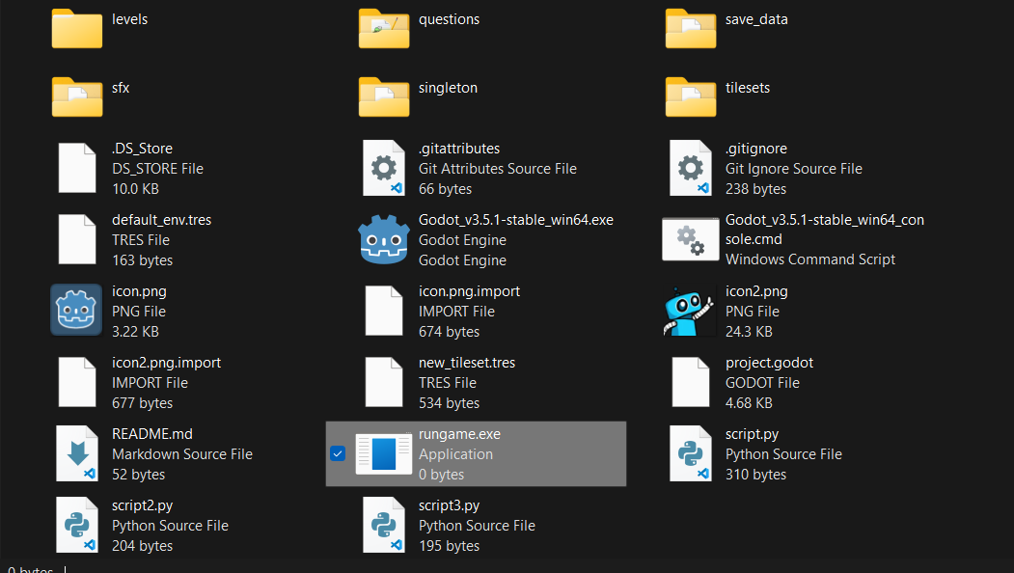

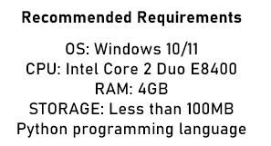



**Gameplay Overview**

Game is played on a computer using the controls indicated by the game wherein you are set up to finish programming tasks that is sectioned off by levels according to the Basic Python Programming Language.

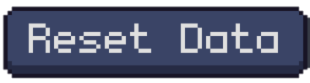The Game boots in the Main Menu wherein you can select levels by pressing the button and to reset your progress data.

After finishing the final level, you are greeted with the Game’s Final Assessment and users gain point by answering the correct answer.

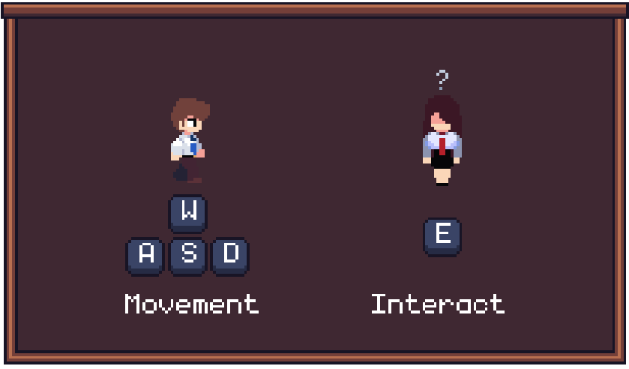**Controls**

**Phone/Simulator**

*Used for simulating the python programming language freely.*

**Diary/Book**

*Used for accessing past lessons*

